SQL Data Types :
Like in other programming languages, SQL also has certain datatypes available. A brief idea of all the datatypes are discussed below.
1. Binary Datatypes :
There are four subtypes of this datatype which are given below :
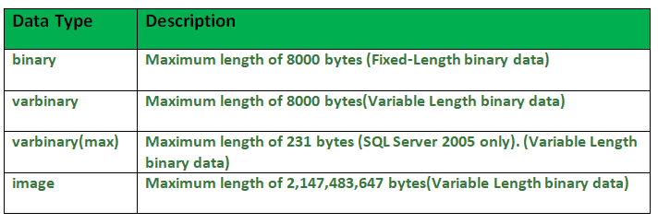 2. Exact Numeric Datatype :
There are nine subtypes which are given below in the table. The table contains the range of data in a particular type.

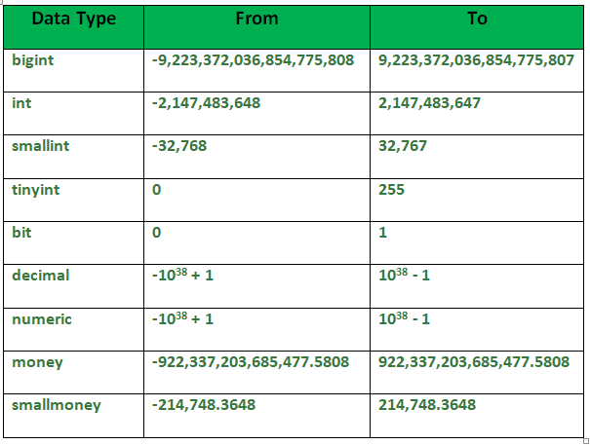
3. Approximate Numeric Datatype :
The subtypes of this datatype are given in the table with the range.
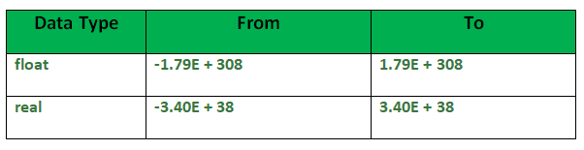
4. Character String Datatype :
The subtypes are given in below table –
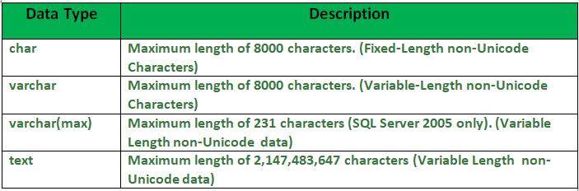
5. Unicode Character String Datatype :
The details are given in below table –
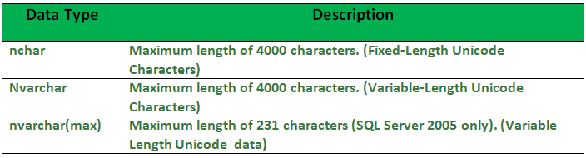
6. Date and Time Datatype :
The details are given in below table.
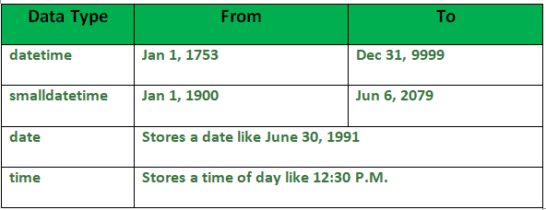

SQL Schema :
A schema is a collection of database objects like tables, triggers, stored procedures, etc. A schema is connected with a user which is known as the schema owner. Database may have one or more schema.
SQL Server have some built-in schema, for example: dbo, guest, sys, and INFORMATION_SCHEMA.
dbo is default schema for a new database, owned by dbo user. While creating a new user with CREATE USER command, user will take dbo as its default schema.
CREATE SCHEMA statement used to create a new schema in current database.
Syntax :
CREATE SCHEMA schemaname
[AUTHORIZATION ownername]
GO
Example –
CREATE SCHEMA geeks_sch;
GO
To select SQL Server SCHEMA :
To list all schema in the current database, use query as shown below :
SELECT *
FROM sys.schemas
Result –
name | schema_id | principal_id
dbo | 1 | 1
guest | 2 | 2
INFORMATION_SCHEMA | 3 | 4
sys | 4 | 4
db_owner | 16384 | 16384
db_accessadmin | 16385 | 16385
db_securityadmin | 16386 | 16386
db_ddladmin | 16387 | 16387
db_backupoperator | 16389 | 16389
db_datareader | 16390 | 16390
db_datawriter | 16391 | 16391
db_denydatareader | 16392 | 16392
db_denydatawriter | 16393 | 16393
Create objects for the schema :
To create a new table named Geektab in the geeks_sch schema :
Syntax :
CREATE TABLE schemaname.tablename(
values... );
Example –
CREATE TABLE geeks_sch.Geektab(
G_id INT PRIMARY KEY IDENTITY,
Name VARCHAR(200),
DOJ DATETIME2 NOT NULL
);

